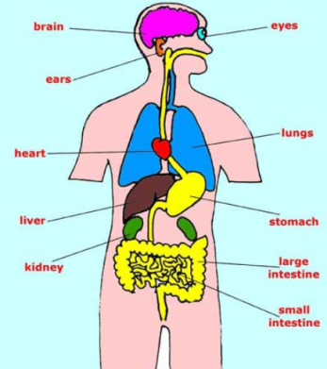
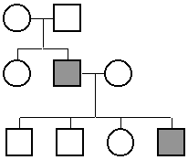
HONORS BIOLOGY SUMMER INFORMATION
2018-2019
ELK RIDGE MIDDLE SCHOOL
Dear Parents and Students:
Congratulations and welcome to Honors Biology for the 2018-2019 school year. I wanted to clarify some points and help you get started on the year.
Students must maintain a B- average in the class in order to remain enrolled. I will check at midterms first quarter and anyone not at that grade level will be transferred to Earth Systems. I will also check again at the end of 1st quarter, midterms of 2nd quarter, etc.
The State of Utah requires that you take three years of science for graduation. One year needs to be in the biology/life sciences and another in physical science. There are complications with graduation credits if you do not complete a full year of Biology. It may mean you take summer school or take an extra year of biology or equivalent class to get caught up. You need to take our class seriously and do your best to maintain the proper grade.
REQUIREMENTS
- You will need a one inch 3-ring binder for our class. We will keep and organize a quarter’s worth of material and it will be graded each time we take a test.
- Sign up for Remind. It is a texting and email notification system that is free for you. I will be able to text &/or email you reminders and updates during the summer and coming school year. Instructions are on the back. I will send several reminders this summer about your homework! You can contact me during the summer via Remind or my school email (vynessa.campos@jordandistrict.org)
SUMMER PROJECT: These assignments are due on the first day of school in the fall. Each one is 50 points. Chose two of the following:
Organ System Story: You will write a story of a particle’s journey through an organ system. This should be completed and turned in through Google Classroom. Simply login to your school Google account and go to classroom.google.com. Join the class by clicking on student and then the + in the upper right corner. The class code is gfsv30. Once you are in the class you can access the instructions and the Google doc on which you can write your story. If you have trouble with the online format, turn in a hard copy the first day of school.
Research: Research inheritance through dominant and recessive traits and how to create pedigree charts. Then create a pedigree chart for your family (if you are not blood related to your family, do not include yourself)
You may choose to trace either eye color, tongue rolling, or attached earlobes through your family. Begin with your grandparent’s generation and continue through three full generations including yourself, your siblings, and your cousins. You must have a minimum of 4 people in each generation. Therefore, there will be a MINIMUM of 12 people for the whole pedigree. Feel free to make your pedigree larger, however, keep in mind that you need to be as accurate as possible. In today’s society, many families are blended with step and half siblings. These individuals can also be included in your family pedigree. Be sure to research on how to do this or simply, do not include them.
Grading Criteria:
Points | Requirements
5 | Use poster board
6 | Title your pedigree, and clearly mark generations I, II, III
5 | All lines must be drawn with a ruler/yardstick
12 | Symbols for a minimum of 12 individuals indicating male, female, presence of trait, absence of trait.
10 | Include a KEY for your symbols
12 | Minimum of 12 individuals’ genotypes.

Note: if you are unable to determine the exact genotype of an individual, you should indicate the possibilities or give an explanation why you can’t.
Extra  Credit | Insert actual pictures of family members wherever possible.
50 | Total Points

Genetic Information
Tongue rolling is a dominant trait. Attached earlobes are a recessive trait.
Eye color is more complicated because there is more than 1 gene that determines eye color and darkness. However, for this assignment, you can make the following assumptions:
- Brown eyes (B) are dominant over Blue eyes (b) and Green eyes (g).
- Blue eyes are co-dominant to Green eyes.
- Hazel eyes (Bg*) can be produced by crossing an individual who is heterozygous Bb with and individual with Green eyes.
Ecosystem Project
Visit a place outside. It could be a forest, desert area, park, wetland, meadow, etc. Spend twenty minutes exploring, observing and thinking quietly. Record your observations while you are there and any questions that you ask yourself.
Build a food web that would exist in that location. It can be partially based on the organisms you observed or through research online. Your food web should include at least 20 organisms. Label each organism with its scientific name and if it is an autotroph or heterotroph. Use arrows to show the direction energy is flowing. Indicate relationships among organisms like: predator-prey, competition or symbiosis. Finally, describe in detail local or global practices that affect this ecosystem.
Follow the directions for the organ system story to access Google Classroom. You will find a template there for this activity. Complete it and turn it in through Classroom. The instructions for accessing the Google Classroom for summer are in the Organ System Story instructions above. If you cannot access Classroom, you may submit a hard copy.
Feel Free to contact me during the summer with questions.

